**ASSIGNMENT NO :-1**

ANSIBLE

Create 3 ec2-machine (Ansible-work-station [AWS] , Ansible-host-1 , Ansible-host-2) : on each ec2- machine do ansible ssh setting . On AWS machine create public and private IP (ssh-keygen) and copy this private Ip to other host machines (ssh-copy-id username@IP) .

**Step1**: Create file vi test.yml



**Step2**: On AWS machine write ansible-playbook script with the help of following points:

* Install git
* Install maven
* Install tomcat (zip file)
* Install java version 1.8

**Step3**: Do git clone (gameoflife repo)

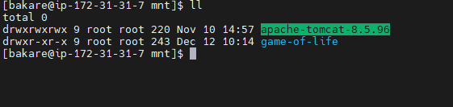

**Step4**: Run mvn clean install

**Step5**: Copy .war file from target file to apache-tomcat/webapps

**Step6**: Run ansible-playbook

**Step7**: Go on ansible-host-1 and ansible-host-2

**Step8**: At last give permission to apache-tomcat

**Step9**: Now start apache-tomcat

* ./startup.sh

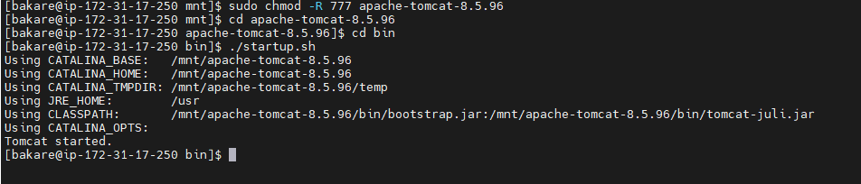

SCREENSHOT OF ANSIBLE-PLAYBOOK START

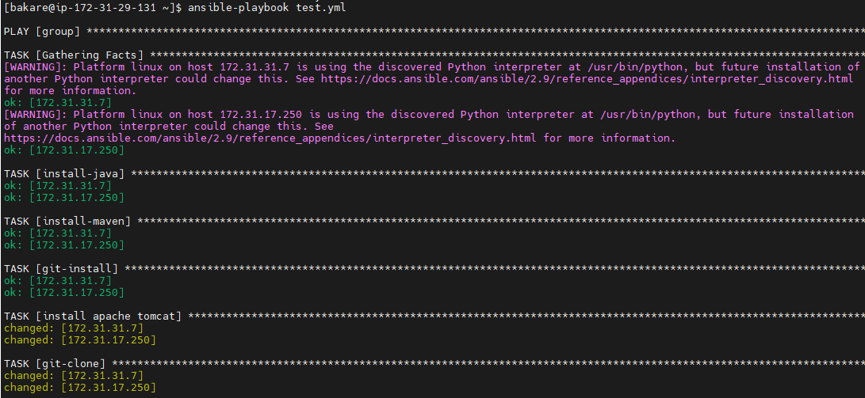

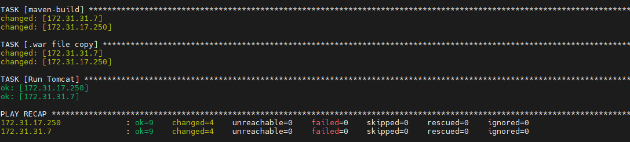

-: OUTPUT :-

ANSIBLE-HOST-1

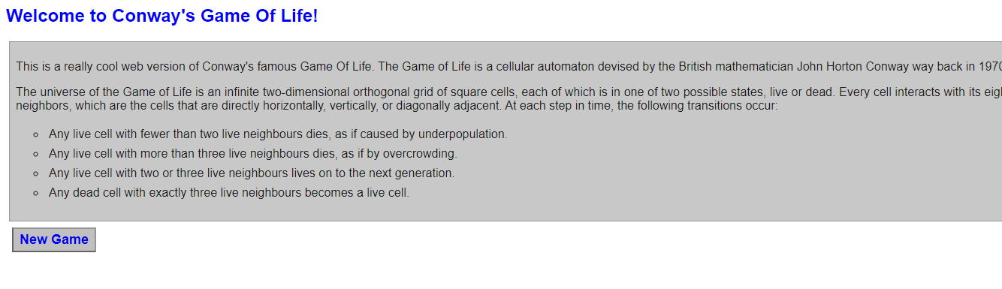

ANSIBLE-HOST-2

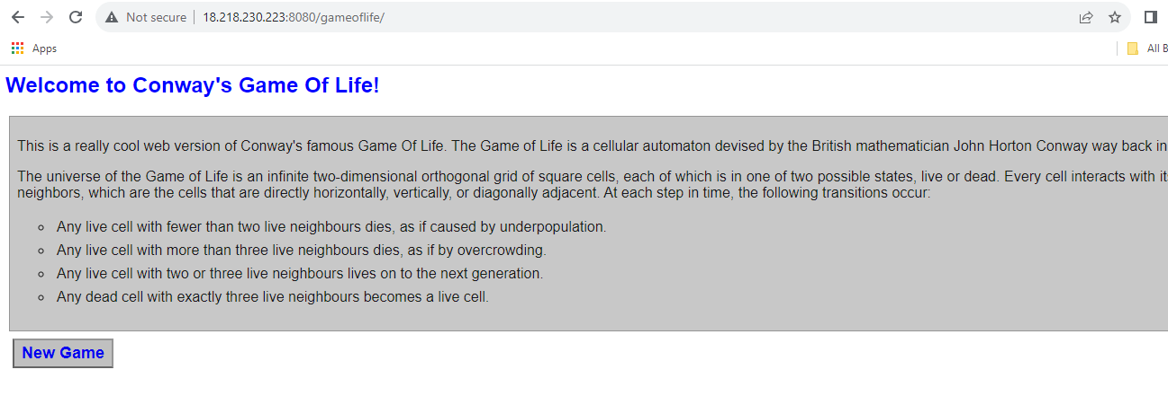

SCRIPT:

---

- hosts: group

user: bakare

become: yes

connection: ssh

gather_facts: yes

tasks:

- name: install-java

action: yum pkg=java-1.8.0-openjdk-devel.x86_64 state=present

- name: install-maven

action: yum pkg=maven state=present

- name: git-install

action: yum pkg=git state=present

- name: install apache tomcat

shell: |

cd /mnt/

rm -rf *

wget https://dlcdn.apache.org/tomcat/tomcat-8/v8.5.96/bin/apache-tomcat-8.5.96.zip

unzip apache-tomcat-8.5.96.zip

chmod -R 777 apache-tomcat-8.5.96

rm -rf apache-tomcat-8.5.96.zip

- name: git-clone

shell: |

cd /mnt/

git clone https://github.com/Bamruta/game-of-life.git

- name: maven-build

shell: |

cd /mnt/game-of-life/

mvn clean install

- name: .war file copy

shell: cp /mnt/game-of-life/gameoflife-web/target/gameoflife.war /mnt/apache-tomcat-8.5.96/webapps/

- name: Run Tomcat

service: name=tomcat state=started enabled=yes